Grades 1-3 School Supply Lists
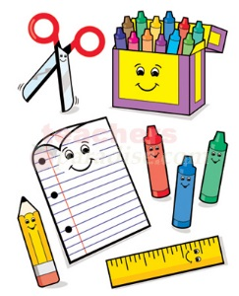
SACRED HEART SCHOOL SUPPLY LIST
The following is the initial supply list for the 2019-2020 school year. This year, you can order your child’s school supplies online as a whole package (with the exception of shoes, Kleenex and a few other items). See attached package or the school website for details. If you choose not to use this option, please note that we do not sell supplies from the school, so you will have to purchase them in time for your child’s first day. We have found in the past, that as we get further into the school year, students tend to get low on certain supplies. Please check with your child periodically to see if they require any additional supplies. Also from time to time students may be asked to bring additional supplies aside from the ones listed below.
PLEASE REMEMBER TO LABEL EVERYTHING - INCLUDING SHOES
GRADE ONE
10 – HB pencils
2 – Pencil erasers (pink or white only)
6 – Small glue sticks
1 – 24 pack CRAYOLA crayons
1 – 12 pack pencil crayons (twistable very user friendly)
2 – Fine tip dry erase whiteboard marker
1 – Package 8 various colours, duo tangs
1 – Pair metal scissors (FISKARS)
2 – Plastic Pencil boxes (No Zipper Cases)
1 – ½ interlined, ½ plain notebook (72 page, 7” x 9”)
1 – Blank notebook (no lines)
1 – Set of good quality headphones for computer use (headband style)
1 – Large Kleenex box
1 – Sizeable backpack
1 – Pair of non-marking running shoes for gym use only

PLEASE NO MARKERS, LOOSE LEAF PAPERS, OR PENCIL SHARPENERS
GRADE THREE
50 – HB pencils
8 – White erasers
1 – Metric ruler (cm & mm)
1 – Pair of metal scissors (FISKARS)
1 – Pkg. of pencil crayons
1 – Pkg. of wax crayons
1 – Pkg. of fine tipped markers
1 – Staedtler pencil sharpener with lid
1 – Box of Kleenex
1 – Pencil box
3 – Large glue sticks
1 – Bottle of white glue
1 – Pkg. of loose leaf paper lined (100 sheets)
15 – Duo tangs
2 – Coiled art/scrapbook (large)
1 – Project scribbler (½ plain & ½ lined)
1 – Plain white 1 inch binder
1 – Packages of binder dividers
1 – Backpack
1 – Pair of good quality headphones with microphone
1 – Pair of white soled running shoes for gym use only

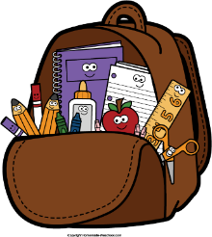
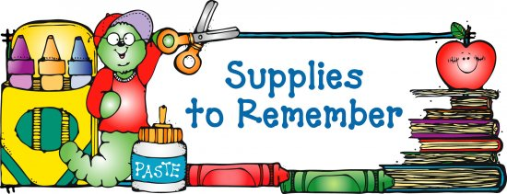
GRADE TWO
1 – 4 pack of ruled notebooks/scribblers
1 Interlined scribbler, full pages
2 – Project scribblers (1/2 plain & half interlined)
50 – HB pencils
1 – Wax crayons (24 pk)
1 - Pencil crayons (24 pk)
4 – Large glue sticks
1 - White glue
6 – Erasers
2 – fine tip dry erase whiteboard markers
1 – Pair or metal scissors (FISKAR)
1 – Hard pencil box
2 – Boxes of Kleenex
1 – Backpack
1 – Pencil sharpener with lid
12 – Duo tangs
1 – Pair of good quality headphones
1 – Pair of white soled running shoes for gym use only

